Howto be a git guru (GG)

FAQ
Q. Why use git anyway?
A. We used SVN before. Migrating from SVN to GIT is a breeze: automated and done to death in the real world. Migrating to TFVCS proved to be a pain in the you-know-what, time consuming and destructive. Then Microsoft announced TFS2013 with git support: that settled it.
Q. Do I have to use git?
A. No. Only old “FreeTechnics” sources are in git. They all reside in the “navvision” project in TFS. If you don't have to change any of these sources, you don't have to use git.
Q. Why not just use TortoiseGit?
A. TurtoiseGit tries to enable the user to use largely the same work-flow as with SVN. This might fool the user into believing that SVN and GIT (and their work flows) are very similar while they are not! SourceTree was chosen for compliance with git work-flow/features whilst enabling the user to get started with git quickly and intuitively. The diff and merge tools included with TurtoiseGit are very good, and can be used with SourceTree as well. You can you TortoiseGit in addition to SourceTree though.
Q. Why not just use Visual Studio's git client.
A. You can! If you want to... Visual Studio's git client used a standard library and is therefore 100% compliant with any git server/client/repo. Furthermore it offers TFS integration on a level that a standard git client doesn't. However, it was made to reside in the sidebar of visual-studio to enable users of this IDE to quickly commit changes, without getting in the way. As a stand-alone client it lacks the overview other clients (or even the command-line) offer.
Q. Why not just use <insert name of desired git client here>
A. By all means, use whatever you're comfortable with. Even though this document describes how to use SourceTree, most things apply to git in general and are applicable to other clients as well. Terminology could be slightly different though, so beware. Note that as the status of you repository is saved locally, (in theory) you can use different clients at the same time, and the status will be identical. Example: You can start a merge from SourceTree, use TortoiseGit merge tools to solve conflicts, and then make the actual commit from the command-line.
Q. Git sucks!/I want SVN back!
A. Deal with it!
Q. How do I …?
A. Keep reading!

Installing the software
- Install SourceTree
- optional Install TortoiseGit and git for windows
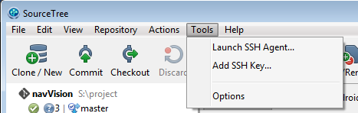
- Got to Tools->Settings (NOT THE SETTINGS BUTTON IN THE TOOLBAR!
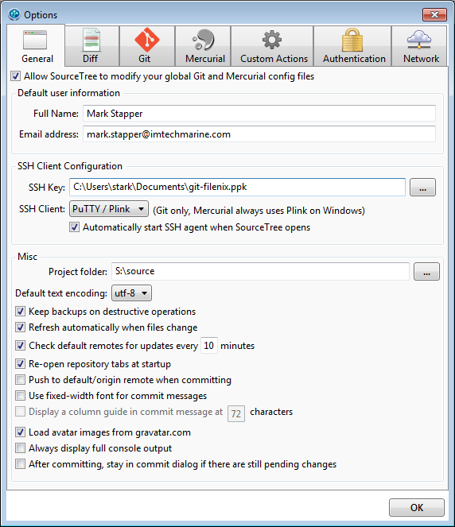
- Fill in your information under “Default user information”
- Under SSH Client configuration: load the key-file you have received from your administrator
- Set the source folder to the default folder you would like your projects to be stored by default.
- To send your local changes back to the server automatically, enable “Push to default/origin remove when committing”.
NOTE: Will slow down workflow considerably
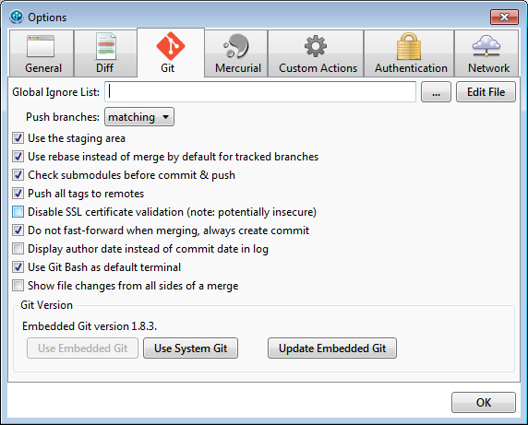
- Under Git enable “rebase instead of merge by default for tracked branches”
- Enable “Do not fast-forward when merging, always create commit
- When you are done setting up SourceTree, click “OK”

Getting the sources
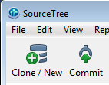
- Click the Clone/New button
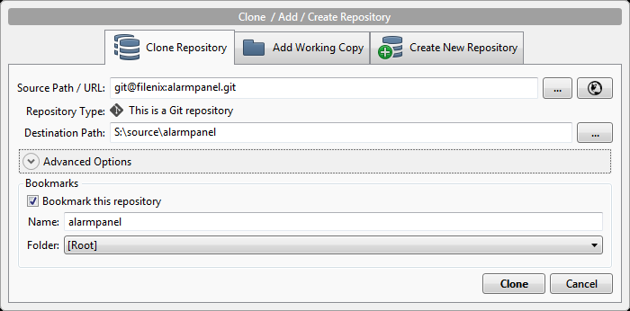
- Fill in the source url as follows:
Filenix: git@filenix:<repository-name>.git
TFS 2013: http://tfs.imtechmarine.com:8080/DefaultCollection/_git/<repository-name>
- Change the Destination Path to anything you like
- Click <done>
- Wait for the source to be fetched from the server
Note: Progress indication isn't available yet, but should be after the update due early 2014

Making changes
- Make changes to your files
- Open SourceTree
- Open the “File Status” tab for you repository, or click “Working Copy” in the left-hand pane
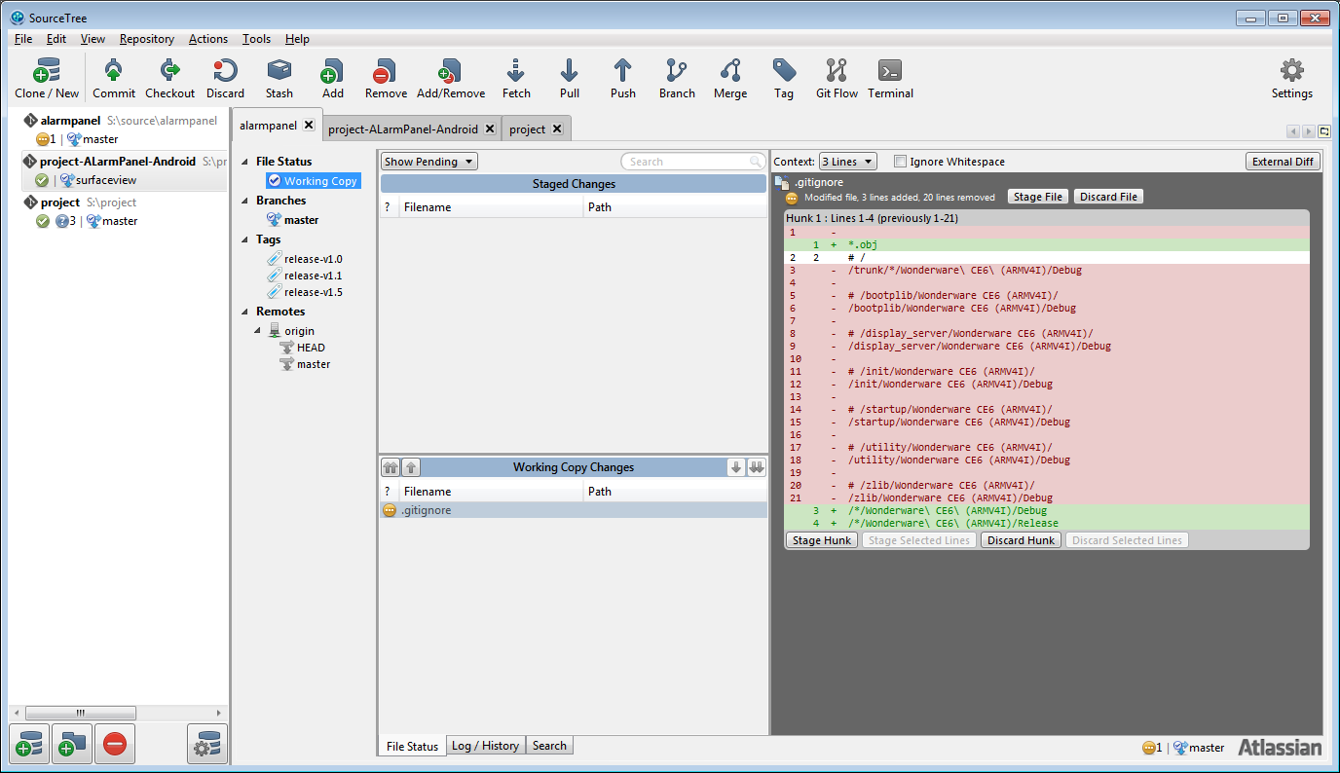
- [Optional] Press <F5> to make sure all changes are loaded
- [Optional] Review your changes per-file, and add files to the “Staged Changes” by dragging them there, clicking the little arrows left and right of “Working Copy Changes” or by right clicking them and choosing: “Add to index”.
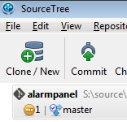
- Press the “Commit” button to bring up the commit dialog
- Write a descriptive and complete message describing your changes:
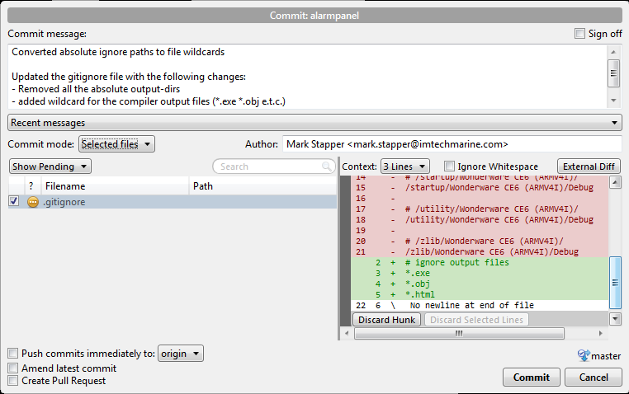Illustration 1: Creating a commit from changes in the working copy directly
- The first line is a short summary of the changes (50 chars or less) followed by a blank line. This is the message shown in the Log/History viewer
- The next section is for describing you changes, and why they were made
- Lastly refer to any tickets these changes were made for, or are otherwise related to your changes. (using “ref #<ticketnr>” to reference, or “fix #<ticketnr> to close a ticked).
- [Optional] select “Push commits immediately to:” when you are ready to send your changes back to the server.
- Click <Commit> when you're finished

Pulling in new changes from the server
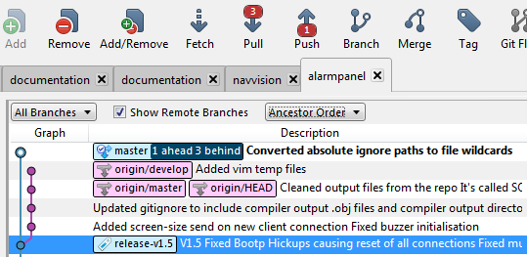
After the last commit 3 changes were made to the master branch on the server, and 1 commit was made locally. This is shown as “3 behind, 1 ahead”. This state is also reflected on the “Push” and “Pull” buttons on the toolbar. Before sending any new commits to the server, any new commits on the server must be pulled in. This is done using the “Pull” button.
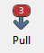
- Click the “Pull” button
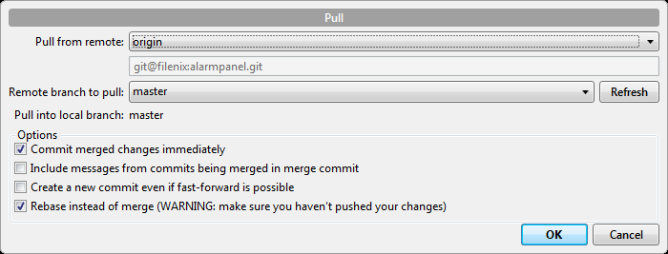
- Make sure “Rebase instead of merge” is enabled.
- Click “OK”
- Git will automatically apply your local changes on top of the new changes of the server. If any conflicting changes are found they should be solved before continuing. Refer to chapter 2.5 for conflict resolution techniques.

Pushing changes to the server
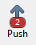
- Click the push button. It will show the number of commits you are ahead of the server
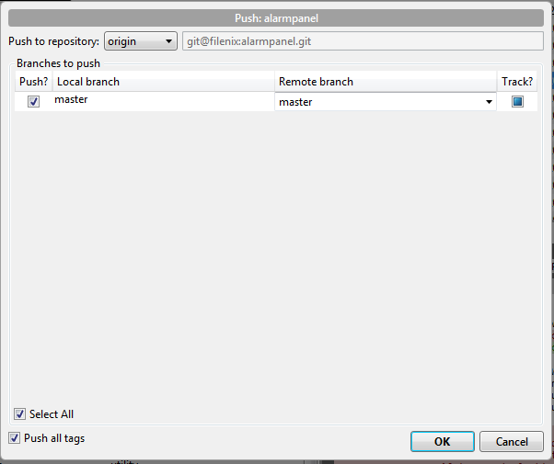
- Select the server and branches you wish to push (it's possible to push multiple branches at once)
- Click <OK>
- Get some coffee/beer
- Rest assured that you are now a GIT n00b

Advanced source-control with git

Creating a new repository

Creating the local repository
- Click “Clone/New”
- Open the tab “Create New Repository”
- Choose a destination path and a name for the new repository and click <create>
- Add files to the new repository and commit them.

Creating a new repository on the server
- Choose “Tools->Launch SSH Agent...”
- Launch putty (http://putty.nl/latest/x86/putty.exe)
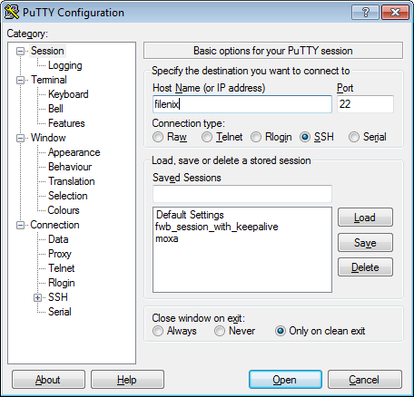
- Type the following under Host Name: “filenix” and hit enter
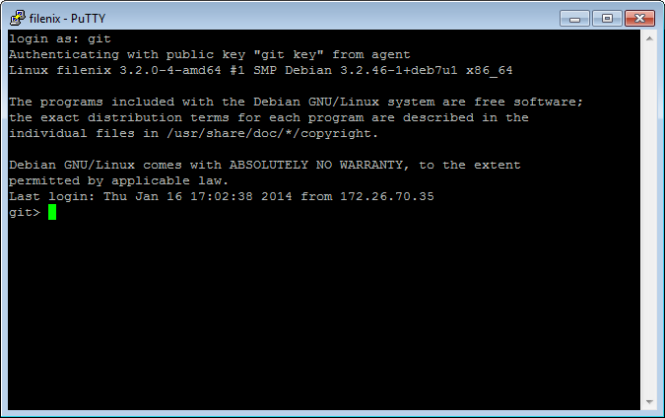
- type git and hit enter
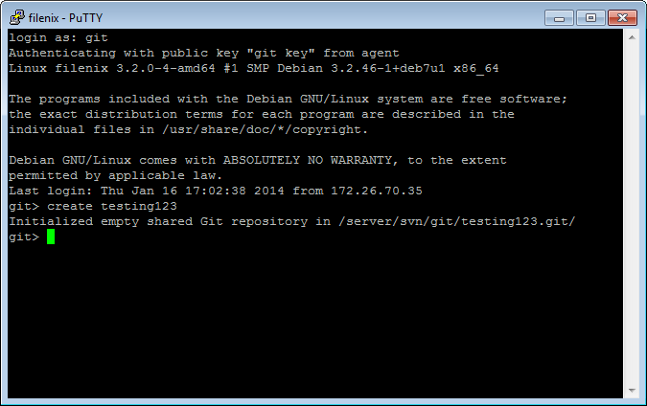
- Type in the following command: “create <repoName>” and hit enter
- Type in the following command: “exit” and hit enter
- Type in the following command: “exit” and hit enter
Notes:
- Using spaces in repository names is currently unsupported, use “-” of “_” instead
- repository names are case sensitive: using uppercase letters is discouraged
- The above example creates a repository named “testing123.git”, and adds it to trac under the name “testing123”
- This repo can be cloned using source URL: “git@filenix:testing123.git”
- The repository will have no files or history until you push to it.
- Is you create a wrong repository by mistake, please contact your administrator

Adding a new remote and pushing to it

- Click the Settings icon on the right end of the toolbar
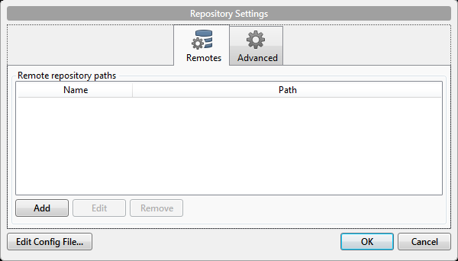
- Click Add
- Enable “Default remote”
- Fill in the path of the new repo on the server (i.e. git@filenix:<reponame>.git
- Click “OK”, and “OK” again
- Click the “Push” button
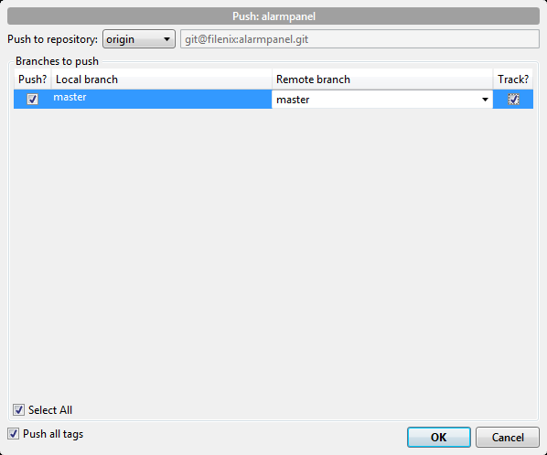
- Enable “Select all” and “Push all tags” and click OK

Branching

Basics
Creating a branch in git is cheap it's a local operation, much like creating a link to a file. Local branches and remote branches can have the same name, and can share part of a history, but are seperate entities. As such, when making changes to a local branch thay are not automatically incorporated in every remote branch and vice-versa.
A branch had at least one parent (commit) and shares it's history with it's parent. From the moment the branch is made, the history of the parent and the new branch start to diverge.
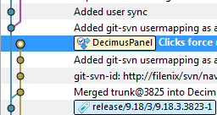Illustration 2: Diverged branches master and DecimusPanel
To include changes from one branch into another branch, these branches can be merged. Merging is largely automated, but in case git is unable to resolve all conflicts, the user must fix them manually.
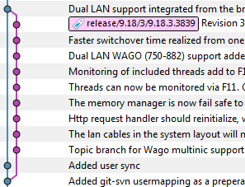Illustration 3: Branch merged back into master
A special kind of merging is called “rebasing”. This way of “merging” rewinds all your changes to the branch start-point, and than re-applies them to the new branch startpoint one by one. This allow conflicts to be solved on a per-commit basis, resulting in less effort per conflict and less chance of breaking things.
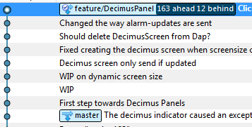Illustration 4: Branch DecimusPanel rebased on top of master
NOTE: Rebasing changes your commits. This means that you cannot rebase a branch that came from the server, and push it back to the server under the same name. In this example it would be impossible to push DecimusPanel back to the server

Branch layout
Depending on the size of the project, using a “Git Flow” branching model is advised. Especially when a project has more comitters, or a large codebase.
The GitFlow branching model is as follows:
Branch name/location | origin | merges | Purpose and way of use
master | None | release, develop, hotfix | The stable branch. This branch reflects the state of the last released version at all times. This branch only merges from other branches. NO DIRECT COMMITS!
develop | master | master, feature, (release, hotfix) | Development branch. This branch is the main line of development. Small changes/bugfixes can be comitted directly to this branch. Large changes (new features) should be merged in from other branches
release/<version> | develop | hotfix | Release branches are created when work begins on a new major release. It allows for testing and bugfixes to be applied before the version is actually released, whilst development can continue on other branches.
Feature/<#-name> | develop | develop | Feature branches are used to implement new features that require longer development, or impact larger parts of the system.
hotfix/<version-#> | master, release | None | Used to fix critical bugs in already released versions. This isn't necessarily the latest version!

SourceTree provides tools to create branches in the right place automatically.

Checking out a branch
To checkout a branch, simply double click it's name. If this is a remote branch, you are asked to create a local branch. Simply click “OK” to create the local branch and checkout that local branch.

Creating a new local branch
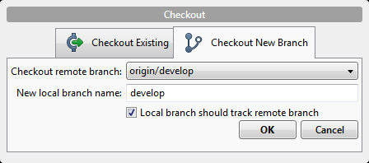Illustration 5: Checking out remote branch "develop"
You can branch from any existing commit in the history of you repository. Simply select the commit you want to branch from to use it as the parent for your new branch.
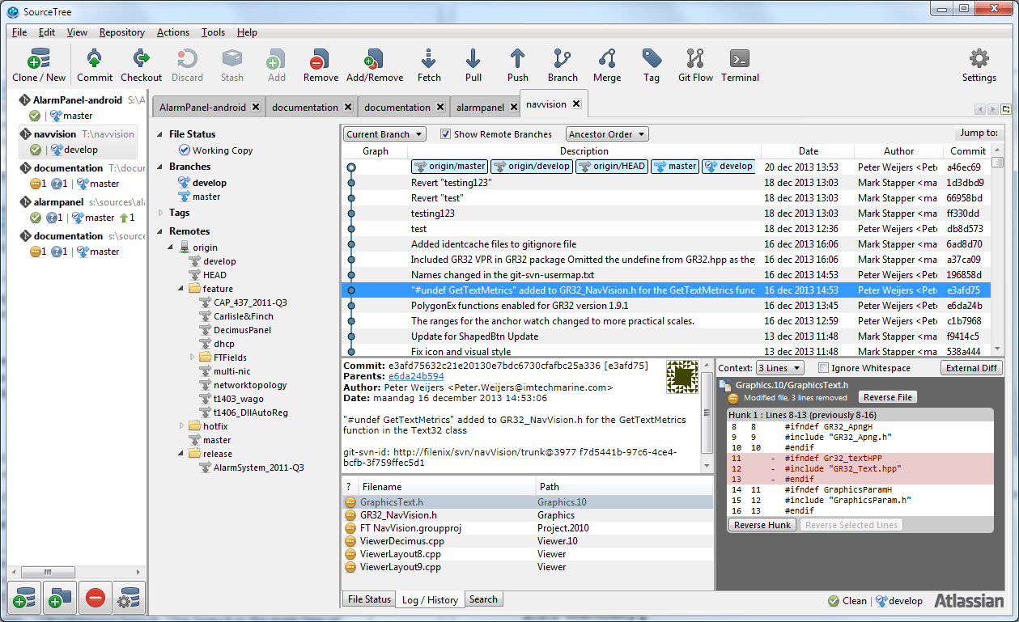Illustration 6: Parent commit selected to begin branching

- Right click the commit to branch from and select “Branch...”, or click the Branch button to branch from the current branch HEAD
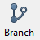
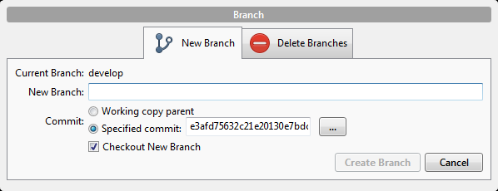
- Name your new branch according to the branch layout used by the project
- Click “Create Branch” to create and checkout the new branch

Merging
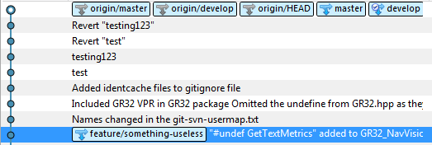Illustration 7: New branch created from an old commit
Merging is a way to include changes from one branch, into another branch. This is used to include changes from the develop branch into the stable master branch when releasing a new version, or to incorporate new features in the development branch. Merging in git is done using a 3-way merge algorithm. This means that the two branches you wish to merge are searched until a common ancestor is found (the point you branched from the develop branch for instance)
- Checkout the branch you wish to merge changes into
- Right click on the branch/commit from where you wish to include changes/commits from
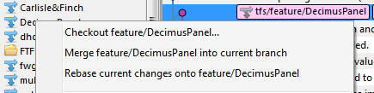
- Select “Merge <branch/commit name> into current branch”
- When merging a feature or release branch, select “Create new commit even if fast-foward is possible”
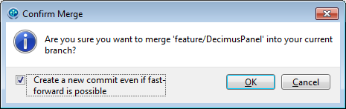
- Click <OK>

Rebasing
Rebasing is a special kind of merging. Merging is done by comparing the tips of two branches, and merging all changes. Rebasing rewinds the changes of the current branch until the common ancestor. Then it checks out the branch you wish to rebase to, and tries to apply the commits that were rewound in reverse. This way the full history is preserved when merging. Any conflicts are resolved using 3-way merge on a per-commit basis. Because the new base branch is checked out before applying the changes of the current branch, “mine” is the new base branch, and “theirs” is the branch that is being rebased.
NOTE: Rebasing changes commits contents and parents. As such, rebasing a shared branch is can cause problems.
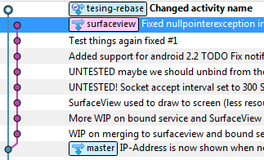
Example:
We have been working on the branch named “testing-rebase” and our colleague has been working on a branch named surfaceview. We haven't pushed our changes to the server yet, and our colleague has. As we are working on the same feature, we decide to merge our changes and continue working on the same branch.
- Checkout the branch you wish to rebase
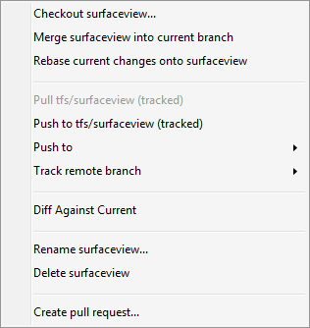
- Right click the branch you wish to rebase onto and click “Rebase current changes onto <branch-name>”
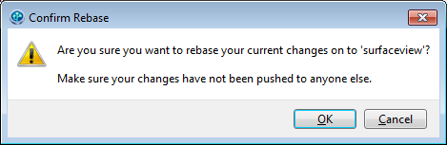
- Click [OK]
Illustration 8: History after rebase is complete

Conflict resolution
Using git encourages the user to branch as much as possible. It's cheap, easy and fast to create branches. But git also makes fast and easy to merge branches. Only bothering the user with actual conflicts, not with every change that ever occurred in branching history. Furthermore, when merging two branches, git looks at their common history, and uses this as the base for the merge operation. Resulting in smaller diff's and easy merging.
As discussed before, there are two ways to merge branches: merging and rebasing. They are fundamentally different on the branch level. When it comes to merging differences on the file level, merging changes is done the exact same way: use mine, use theirs or three-way merging.
When a conflict is found SourceTree notifies the user using a popup screen. These conflicts can be investigated and resolved from the “File Status” tab.
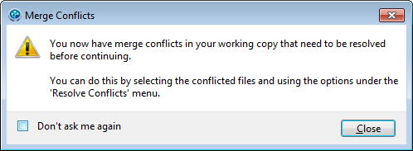
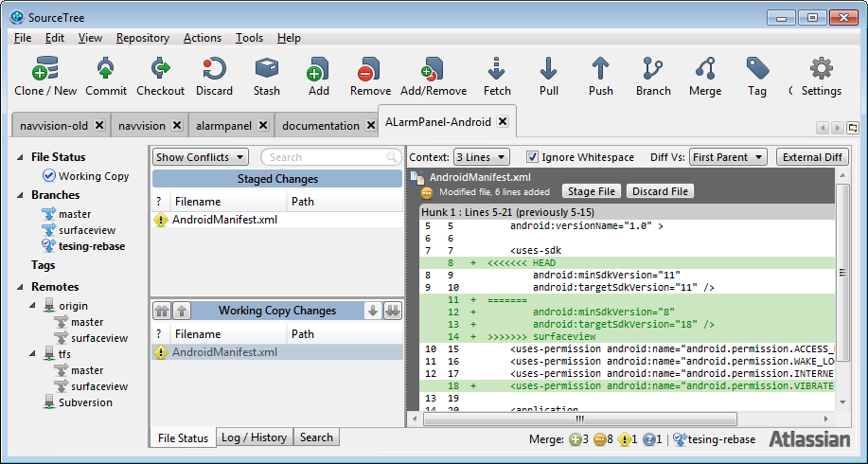
Right clicking on a conflicting file , and choosing “Resolve Conflicts” shows you different ways to solve conflicts.
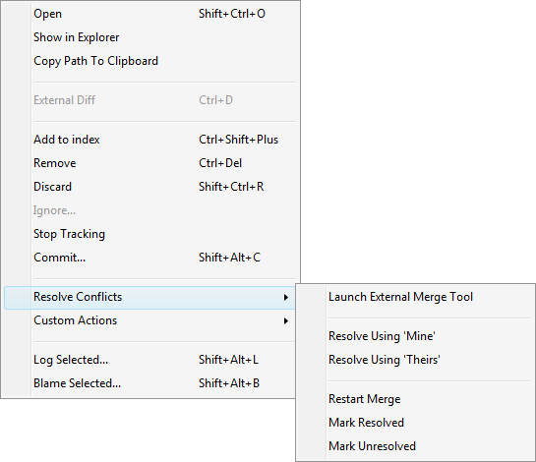

Resolve Using mine/theirs
This is the simplest way of conflict resolution. Simple use the version of the branch you are currently on(mine), or the version of the branch you are merging into the current branch(theirs). To resolve conflicts using this technique simply select the corresponding options from the context menu.
NOTE: When rebasing “mine” and “theirs” are swapped.
Let's look at the following example:
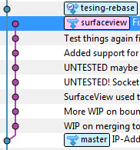
When merging (or rebasing onto) surfaceview testing-rebase a conflict is found in the file “AndroidManifest.xml”. The branch testing-rebase changes the xml-attribute “android:targetSdkVersion” to “11”. The branch “surfaceview” changes the xml-attribute “android:minSdkVersion” to “8” and “android:targetSdkVersion” to “18”.
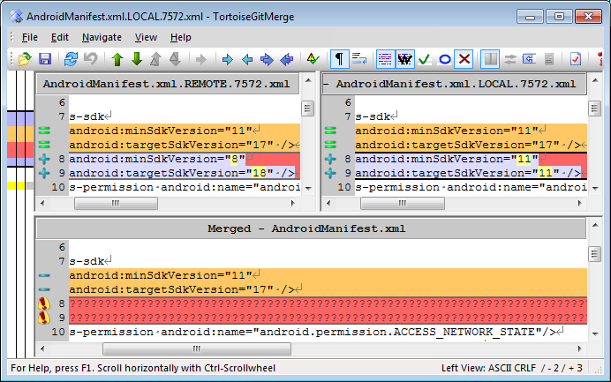Illustration 9: Mine (left) and theirs (right) when merging
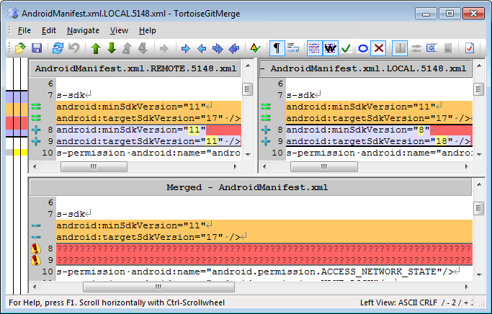Illustration 10: Mine (left) and theirs (right) when rebasing

Three-way merging a file
When changes from both branches need to be incorporated a three-way merge is required. A thee-way merge calculates 2 sets of differences: mine ↔ base and theirs ↔ base, where base is their common ancestor. These changes are merged to a third-file, the eventual version to be checked in.
- Select “Launch External Merge Tool” from the “Resolve Conflicts” context menu
- Select a conflicting row (marked red) and select either option from the “edit” menu.
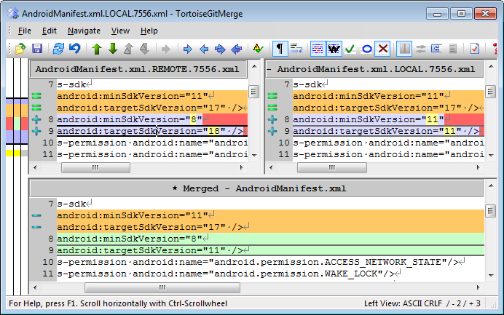
- When all conflicting lines have been processed, save the file and close the application.
- When all merge conflicts have been resolved, commit(while merging) or select “Action->Continue Rebase”

Using GitFlow

Getting started with git-flow
To start using git flow, use the GitFlow button on the main toolbar.

Based on the current state of the repository, the Git-flow button will bring up a dialog with the most likely action you’d want to perform next. So if you haven’t set up git-flow on this repo yet, it’ll help you do that by default. If you’re on the development branch, it will default to starting a new feature. If you’re already on a feature branch, it will offer to finish your current feature and merge it back into the development branch, and so on. You can always get to all the other git-flow actions via this button as well, but most of the time the default option will be the action you’ll want SourceTree to perform.
If you haven’t used git-flow already on this repository, the first thing SourceTree will do is initialise your repository to use it. You’ll probably just want to use the defaults in the initialisation window so that’s not covered here. For more details please see the Help section included in SourceTree. Next up, we’ll concentrate on the actions we can perform with Git-flow and SourceTree.

Starting a feature
You can commit trivial changes directly to the development branch (‘develop’) if you like, but any time you start on something non-trivial you should explicitly start a new feature. This ‘Start Feature’ action will be the default action when you click the Git-flow button if you are currently on the dev branch.
The first thing to note is the ‘Preview’ window, which is present on all of the action dialogs and shows you what will actually happen when you confirm the dialog. In this case, a new feature branch called ‘feature/my-new-feature’ will be created (I used the default prefix when I initialised this repository). You commit your feature implementations to this branch. If you want, you can push the feature branch to your remote while you work on it (your team can decide on whether that’s normal practice or not).
If at any time you want to switch branches, either to another feature branch or to somewhere else, just use the normal mechanisms in SourceTree to do that, such as double-clicking a log entry or a branch in the sidebar. Git-flow determines your context simply from the branch you currently have checked out, so it’s fine to jump around if you like.

Finishing a feature
Eventually when you’re done implementing a feature, use the ‘Finish Feature’ action (again, this will be the default action from the toolbar button if you’re on a feature branch):
Again, the Preview shows you what will happen — the feature branch will merge into the main development branch, essentially queueing it for inclusion in the next release. Feature branches are deleted by default but you can opt to retain them if you like.

Starting a release
You start a release branch when you want to start preparing a new release, which probably coincides with a feature freeze. Accessing the Start Release option –either from the menu or from the toolbar action selection window — brings up the following dialog:
The preview shows that a new release branch will be created. Most of the time, you want to start the release from the latest commit in the development branch, but you can choose to base it on another commit if you wish. This essentially freezes the release, so it’s not affected by subsequent development. You can also perform preparatory tasks for the release process on this branch, such as updating the version number in source files, updating changelogs, or committing other tweaks. Once these tweaks are done, you can finish the release as described below.

Finishing a release
Once all the adjustments required for the release are done and committed, you can conclude the release process.If you’re on the release branch already, the git-flow button will show you the following dialog:
The preview illustrates that the release branch will be merged into the production branch (‘master’ or ‘default’ normally) to indicate an update to the deployed version. Sourcetree will also create a tag here for the release. The release branch changes will also merge back into the development branch to make sure the develop branch is kept up to date.

Starting a hotfix
What if you need to just fix a bug on the latest release? You don’t want to create a new release, because that will pick up the recent changes from the development branch. So instead, you can start a hot fix:
Hot fixes always start from the latest production code from the ‘master’ or ‘default’ branch. Other than that, they’re basically the same as release branches. Moreover, when you’re finished with the hot-fix, they behave the same way as finishing a release branch. The changes are merged back into both the production branch and the development branch, and a tag is created on the production branch for the hot fix release.

Using SourceTree with TrueCrypt
- Install TrueCrypt (http://www.truecrypt.org/downloads)
- Create a TrueCrypt disc/volume to keep your sources on. Make sure it is large enough(we'll assume drive T:)
- Put your private key on the T drive (git-filenix.ppk)
- In SourceTree set your Projects folder to “T:\”
NOTE: If you open SourceTree before the T-drive is available, you'll have to close SourceTree and reopen it.
- If required, use the “junction” tool to create links from your S-drive to the t-drive
S:\>junction project t:\navvision

Junction v1.06 - Windows junction creator and reparse point viewer
Copyright (C) 2000-2010 Mark Russinovich
Sysinternals - www.sysinternals.com

Created: S:\project
Targetted at: t:\navvision
S:\>dir
...
17-01-2014 12:34 <JUNCTION> project [\??\t:\navvision]
…

External diff- and merge-tools

Diffing binary files
Generally it's impossible or impractical to diff binary files, as they are generally large, and the differences meaningless. But sometimes, these binary files can be converted to a format that allows for meaningfull diff's to be generated. This applies to binary formats used by word-processors for instance. This chapter describes ways to diff those binary files.

Auto-convert to text
Git for windows automatically converts .docx and .pdf files to text when you run the 'git diff' command. It does not do this with .odt files used by OpenOffice. To enable a custom diff configuration for these files, do the following:
- Download the odt2txt.exe
- Copy it to you personal binary-folder so git will find it
stark@FTMARK /s/
$ mkdir ~/bin
stark@FTMARK /s/
$ cp odt2txt.exe ~/bin/
- Configure the textconv driver on your computer
stark@FTMARK /s/svn2git/documentation (master)
$ git config --global diff.odf.textconv odt2txt

stark@FTMARK /s/svn2git/documentation (master)
$ git config --global diff.odf.cachetextconv true
- Configure the attribute file for your repository by placing a “.gitattributes” file with the following contents in the root of your repository:
*.ods diff=odf
*.odt diff=odf
*.odp diff=odf

TortoiseGit
TortoiseGit enables the user to view differences visually using the program that one would normally use to create such files. It would launch Microsoft Word to diff a .docx file, and OpenOffice Writer for a .odt file. To view the differences introduced in a commit simply click the file from the log viewer. To view your current working copy changes:
- Right click the file for which you want to view the changes
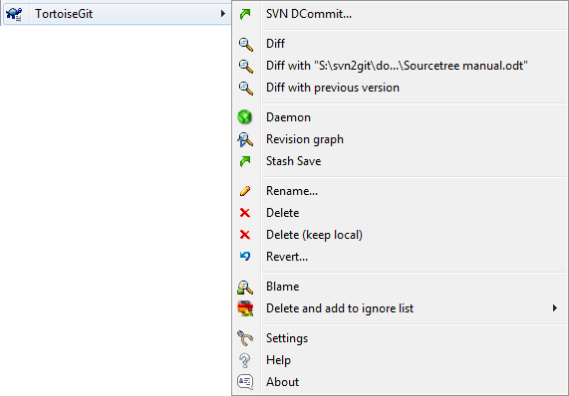
- Navigate to “TortoiseGit->”Diff”
- OpenOffice will open and show you a list of your changes that you can accept or reject.
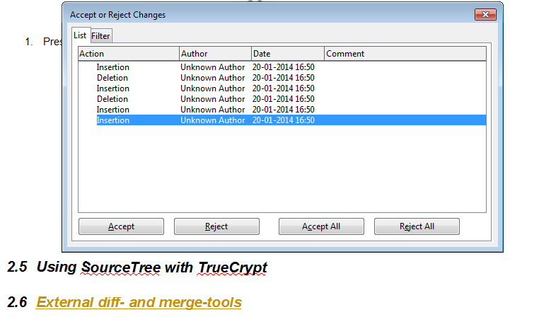
- When all changes are processed save the file, and commit.
Note: This works for simple diff-ing as well as merging.

Git Pro
- RTFM @ http://git-scm.com/book
- Get some coffee/beer
- Rest assured that you are now a GIT GURU!

Troubleshooting

64-bit and more than 4 GB of ram
Git compresses your history very efficiently. In order to do so, it repacks your .git directory every now and then. This process can take up a lot of memory. Due to the fact that git is a 32-bit executable this can cause problems on systems with large internal memory (larger than 4GB). Git will use more and more memory until it simply crashes. To solve this open a terminal from SourceTree and run the following commands:
git config --global --add pack.windowmemory 1G
git config --global --add pack.threads 2

Links
http://git-scm.com/book
http://nvie.com/posts/a-successful-git-branching-model/
http://blog.sourcetreeapp.com/2012/08/01/smart-branching-with-sourcetree-and-git-flow/
http://odt2txt.softpedia.com/

The best IMHO
f:\install\software\Development\sourcecontrol\ or http://www.sourcetreeapp.com/download/
f:\install\software\Development\sourcecontrol\ or http://code.google.com/p/tortoisegit/wiki/Download
f:\install\software\Development\sourcecontrol\ or http://git-scm.com/downloads
Repository names are all lower-case and have .git appended to them
You can find this URL by browsing to the repository using the TFS web-interface and copying the URL from the address-bar, or clicking “clone” top-right on the page.
When files are “Staged” they are actually copied from your working copy to a place called the “staging area” or “index”. If a file changes in the working copy after they have been staged(thus copied to the index directory) you need to re-stage the file (copy the newly changed file to the index). Staged changes aren't shown when showing differences between your working copy and the latest commit. This way it's possible to create large commits while reviewing changes file by file, whilst keeping an eye on global changes.
Use this option with caution if you work on a repository with other people as their changes might conflict with yours. Refer to chapter 2.5 Conflict resolution for ways to solve these conflicts
Documentation projects, or internal projects don't require this branching model, but can borrow parts of it's general intentions
These changes are already pulled in from “master” however, if they have to be in de development branch before they are merge into master, they can be merge into develop
Ticket number if feature is requested from a ticket
Hotfix number
If the branch still exists, otherwise a release tag is used to branch from
http://technet.microsoft.com/en-us/sysinternals/bb896768.aspx

